30.Write a short essay talking about a scenario: Good news everyone! We (Wide World Importers) just brought out a small company called “Adventure works”! Now that bike shop is our sub-company. The first thing of all works pending would be to merge the user logon information, person information (including emails, phone numbers) and products (of course, add category, colors) to WWI database. Include screenshot, mapping and query.

Our team’s code did not run successfully. We made a lot of progress but still stuck on the datatype converting. Attached below is the result code showing our understanding, progress and where we get stuck.

**IF OBJECT_ID(N'AdventureWorks2019.dbo.person', N'U') IS NOT NULL**

**DROP TABLE AdventureWorks2019.dbo.person;**

**GO**

**CREATE TABLE AdventureWorks2019.dbo.person(**

**BusinessEntityID int not null,**

**FullName nvarchar (50) Not null,**

**PreferredName nvarchar (50) NOT NULL DEFAULT 'None',**

**SearchName nvarchar (101) NOT NULL DEFAULT 'None',**

**IsPermittedToLogon bit not null DEFAULT 0,**

**LogonName nvarchar (50),**

**IsExternalLogonProvider bit not null DEFAULT 0,**

**Hashedassword varbinary(max),**

**IsSystemUser bit not null DEFAULT 0,**

**IsEmployee bit not null DEFAULT 0,**

**IsSalesperson bit not null DEFAULT 0,**

**UserPreferences nvarchar(max),**

**PhoneNumber nvarchar (20),**

**FaxNumber nvarchar(20),**

**EmailAddress nvarchar(256),**

**Photo varbinary(max),**

**CustomFields nvarchar(max),**

**OtherLanguages nvarchar (max),**

**LastEditedby INT NOT NULL DEFAULT 0,**

**ValidFrom datetime2(7) NOT NULL DEFAULT GETDATE(),**

**ValidTo datetime2(7) NOT NULL DEFAULT '9999-12-31 23:59:59.9999999'**

**)**

**GO**

**--check table**

**select * from AdventureWorks2019.dbo.person**

**GO**

**--insert value**

**INSERT INTO AdventureWorks2019.dbo.person (BusinessEntityID,FullName,EmailAddress,PhoneNumber)**

**SELECT p1.BusinessEntityID, CONCAT(p1.FirstName,' ',p1.LastName) as FullName, p2.EmailAddress,p3.PhoneNumber**

**FROM Person.Person p1 JOIN Person.EmailAddress p2 ON p1.BusinessEntityID = p2.BusinessEntityID**

**JOIN Person.PersonPhone p3 ON p1.BusinessEntityID = p3. BusinessEntityID**

**order by p1.BusinessEntityID**

**GO**

**--check table**

**select * from AdventureWorks2019.dbo.person**

**GO**

**--add personID to match with WWI**

**ALTER TABLE AdventureWorks2019.dbo.person**

**ADD PersonID int IDENTITY(3262,1)**

**GO**

**select * from AdventureWorks2019.dbo.person**

**GO**

**--alter personID datetype to match with WWI**

**ALTER TABLE AdventureWorks2019.dbo.person**

**ALTER COLUMN PersonID PRIMARY KEY**

**GO**

**--**

**INSERT INTO WideworldImporters.Application.People**

**select PersonID,FullName,PreferredName,SearchName,IsPermittedToLogon,LogonName,IsExternalLogonProvider, Hashedassword, IsSystemUser, IsEmployee, IsSalesperson,**

**UserPreferences,PhoneNumber, FaxNumber, EmailAddress,Photo,CustomFields, OtherLanguages, LastEditedby, ValidFrom, ValidTo**

**from AdventureWorks2019.dbo.person**

31. Database Design: OLTP db design request for EMS business: when people call 911 for medical emergency, 911 will dispatch UNITs to the given address. A UNIT means a crew on an apparatus (Fire Engine, Ambulance, Medic Ambulance, Helicopter, EMS supervisor). A crew member would have a medical level (EMR, EMT, A-EMT, Medic). All the treatments provided on scene are free. If the patient needs to be transported, that’s where the bill comes in. A bill consists of Units dispatched (Fire Engine and EMS Supervisor are free), crew members provided care (EMRs and EMTs are free), Transported miles from the scene to the hospital (Helicopters have a much higher rate, as you can image) and tax (Tax rate is 6%). Bill should be sent to the patient insurance company first. If there is a deductible, we send the unpaid bill to the patient only. Don’t forget about patient information, medical nature and bill paying status.

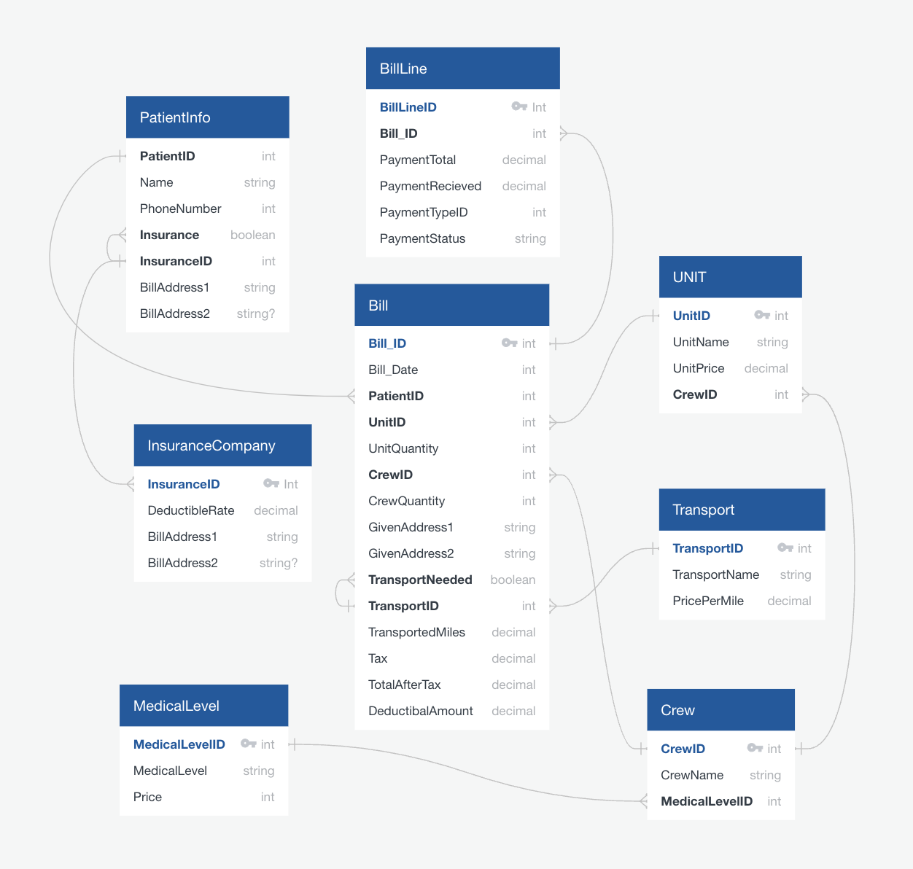

https://app.quickdatabasediagrams.com/#/